Veritas Classical Schools
Science
Assignment Sheet
Mrs. Julie O’Bryant
julieobryant@gmail.com
615-541-9860

Our Planet Earth Assignment Sheet #9
Lessons 19 - 21
Lesson 19 – Plate Tectonics
- Read pages 76-79 in the textbook.
- Define the following vocabulary terms using the blanks pages provided. Be sure to write a complete definition and add an illustration for each one:
__plate tectonics __subduction zone
__Rodinia __rifting
__subduction __slip-strike faulting
- Complete the notebooking pages for lesson 19 and add them to your binder.

Lesson 20 – Mountains
- Read pages 80-81in the textbook.
- Define the following vocabulary terms using the blank pages provided. Be sure to write a complete definition and add an illustration for each one:
__elevation
__actual height
- Complete the notebooking pages for Lesson 20 and add them to your binder.

Lesson 21 – Types of Mountains
- Read pages 82-85 in your textbook.
- Define the following vocabulary terms using the blank pages provided. Be sure to write a complete definition and add an illustration for each one:
__depositional mountain __monocline
__erosional mountain __anticline
__fold mountain __syncline
__fault __dome
- Complete the notebooking pages for Lesson 21 and add them to your binder.

Homework has been completed and checked by a parent.
Student Name: _____________________ Parent Signature: ___________________

Lesson 19 – Plate Tectonics

Prior to the 1960’s, what did most scientists believe about the earth’s crust?
________________________________________________________
________________________________________________________
________________________________________________________

What is the currently accepted theory about the earth’s crust?
_____________________________________________________
_____________________________________________________

What is the name of the theory? _____________ ________________

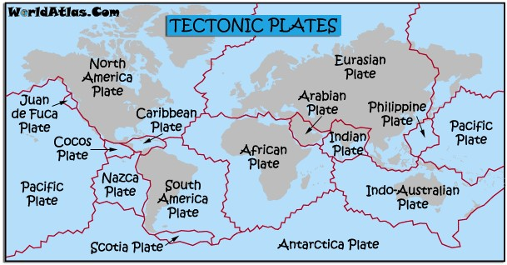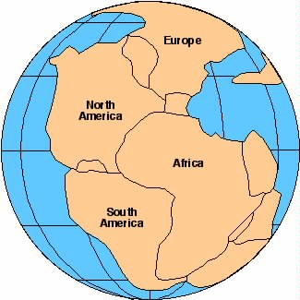

Explain Holmes’s theory of how a single landmass became the seven (7) continents we have today. What is the slow movement called?
_____________________________________________________
_____________________________________________________ _____________________________________________________

Lesson 19 – Plate Tectonics

What are the two names for a single original land mass?

1.
2.

What is the creationist theory about how the single landmass became the 7
continents? __________________________________________ _____________________________________________________
What is this view called? ____________ ___________ __________

Genesis 1:9 states, “Let the waters under the heavens be gathered together into on place, and let the dry land appear.” What does this tell us about the original
design of the earth?

The Hebrew word baqa, for “broken up” means

Genesis 7:11 states, “all the fountains of the great deep were broken up.” What do you think this verse is describing? ______________________________
_____________________________________________________
_____________________________________________________

It is believed that there are ______ tectonic plates:
_____ major plates ______ minor plates

Lesson 19 – Plate Tectonics

Explain continental drift ______________________________________________________________________________________
__________________________________________________________________________________________________________________
__________________________________________________________________________________________________________________

What are the three (3) ways that tectonic plates move? (top of page 78)
1.
2.
3.

What are the two most common results of these movements? (page 78)
1.
2.

What is the nickname of the area surrounding the Pacific Ocean? (Pg78)

(3 words)

Why is it called that?

Explain sea-floor spreading

Lesson 20 – Mountains
What is a summit? (Do not look up actual definition- Use the context of the book)

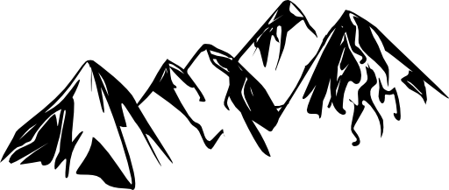

What is a series of mountains in a given area called?

What is a series of mountain ranges called?

What is the highest mountain in the world?

What is the longest/most extensive mountain system in the world called?

What is the highest mountain range in the United States?

Lesson 20 – Mountains
What is the largest mountain range in the Eastern United states?

Who first climbed Pike’s peak?

What patriotic song was written on Pike’s Peak?

Lesson 21 – Types of Mountains

How are most mountains classified?

What are the four (4) categories of mountains?
1.
2.
3.
4.

Describe the three (3) ways depositional mountains are formed: (pg. 82-83)
1.
2.
3.

What are the two (2) most common kinds of mountains?
1.
2.

Lesson 21 – Types of Mountains
What are the five (5) basic types of folding that can occur to create mountains:
1.
2.
3.
4.
5.

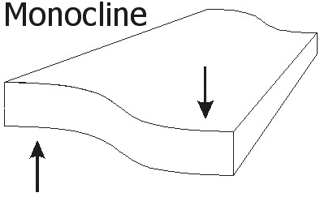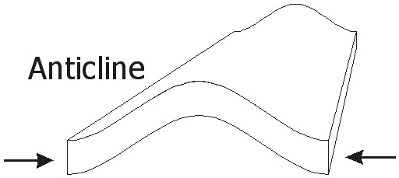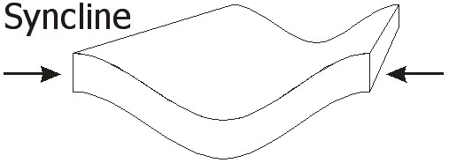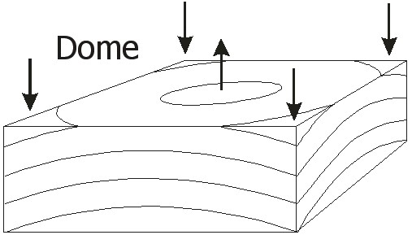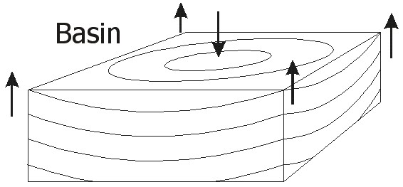
NameDate

