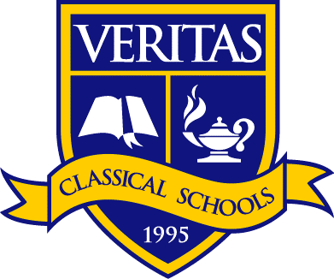

Veritas Classical Schools – Nashville
3rd and 4th Grade

8:45-9:00 Student Arrival
9:00-9:30 Morning Meeting & Bible
9:30-10:15 IEW & Grammar
10:15-10:35 Bathroom Break & Snack Break
10:35-11:00 Literature
11:00-11:30 Vocabulary & Spelling
11:30-11:50 History & Geography
11:50-12:00 Bathroom Break
12:00-12:25 Recess
12:25-12:35 Bathroom Break & Prepare for Lunch
12:35-12:55 Lunch
12:55-1:55 Penmanship & Art/Music Appreciation
1:55-2:00 Dismissal & Science Transition
2:00-3:45 Science

